Before you start that tutorial, make sure you installed Xlink Analyzer according to installation.docx.

# Tutorial

The tutorial will demonstrate usage of Xlink Analyzer using Rvb1/2 complex as example. Rvb1/2 is hexamer composed of three copies of Rvb1 and three copies of Rvb2. The Rvb1/2 complex is a part of INO80 complex, which includes two copies of the Rvb1/2 hexamer and other subunits. The XL-MS data was obtained for the entire INO80 complex (Structure and Subunit Topology of the INO80 Chromatin Remodeler and Its Nucleosome Complex, Cell, 2013).

## Start Xlink Analyzer

1. Start UCSF Chimera
2. Open PDB file with your structure or model
   * *Although loading the PDB file before starting Xlink Analyzer is not necessary, it is useful to have the structure loaded when configuring Xlink Analyzer project in the following steps.*
   * Menu File → Open … and select yRvb12.hexamer.pdb file from example/Rvb12 directory
3. Start Xlink Analyzer:
   * 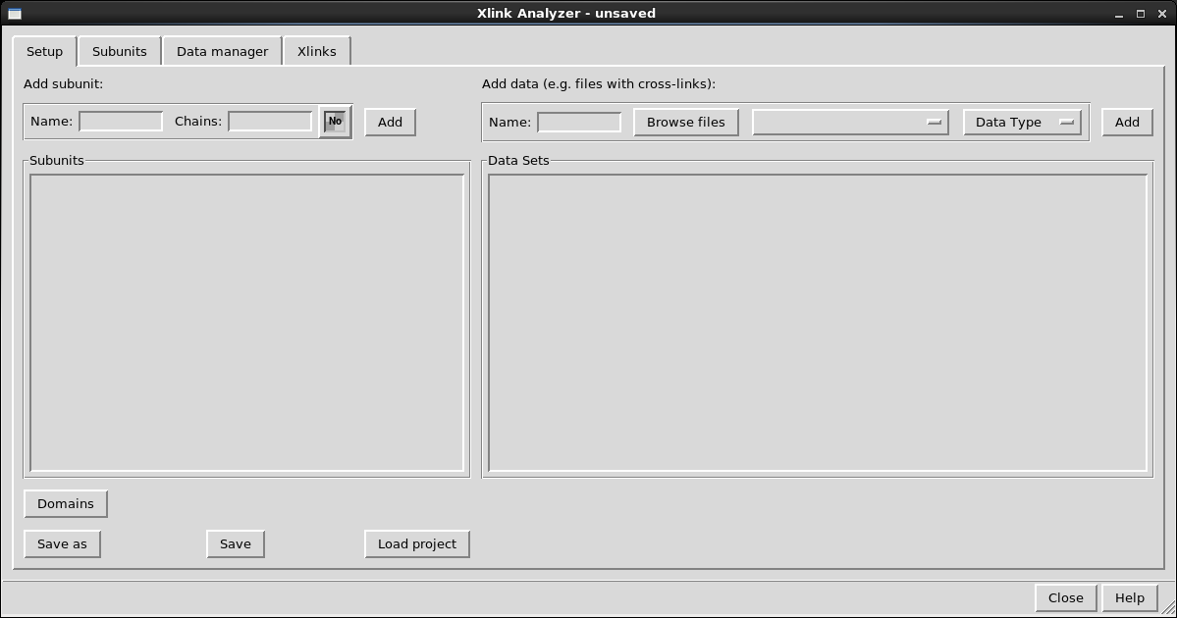Go to Menu Tools → Utilities → Xlink Analyzer

## Set up a new project

To use Xlink Analyzer, you need to set up a project. The project includes information about:

* Subunits of the complex
  + This includes mapping of subunit names to chain IDs in the PDB file
* Cross-linking data
  + This includes links to files with cross-links and mapping of the protein names to subunit names

The project can be saved for later use.

### Create project directory

1. Create a new directory named Rvb12. This directory will serve as a project directory, where you will save all files needed to save the project and open later on this or another computer.  
   *Note: creating a new directory is not mandatory - you can use existing directory. It will be however easier to handle the Xlink Analyzer project if the project directory contains only files for Xlink Analyzer. For example, you can zip and send the project to someone without including all others unnecessary files.*
2. Copy the cross-link files there. The cross-link files for Rvb12 example are located in example/Rvb12/xlinks directory. Copy the entire xlinks directory to the new location.

### Add subunits

1. Add definition of Rvb1 subunit:  
   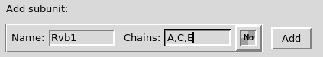  
   Note that Rvb1 corresponds to chains A, C and E in the PDB file.
2. To edit the color, click on the color box 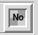
3. In the opened window, type green and press Enter, and close:  
   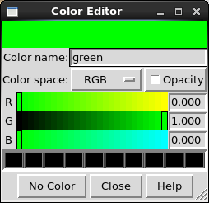  
   The color box should turn green:  
   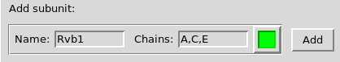
4. Click Add. The subunit definition should appear in the panel below:  
   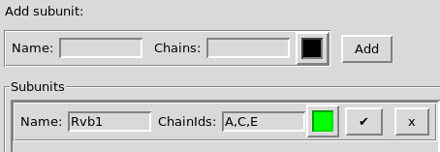  
   You can change the name of the subunit, the chains and colors at any time.
5. Add definition of Rvb2 subunit (typing *cornflower blue* as color):  
   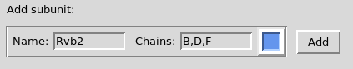  
   You should have to subunits added now:  
   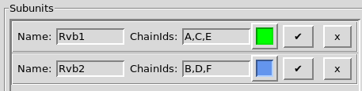
6. 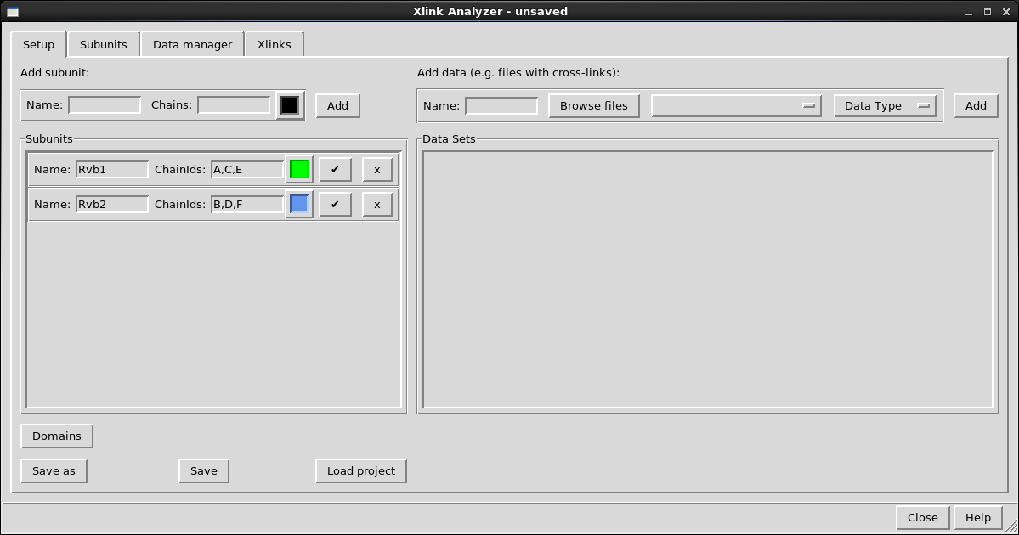Save the project as file with name Rvb12.json in the Rvb12 directory you have created:
7. Check if subunits were configured properly.
   1. Switch to Subunits tab

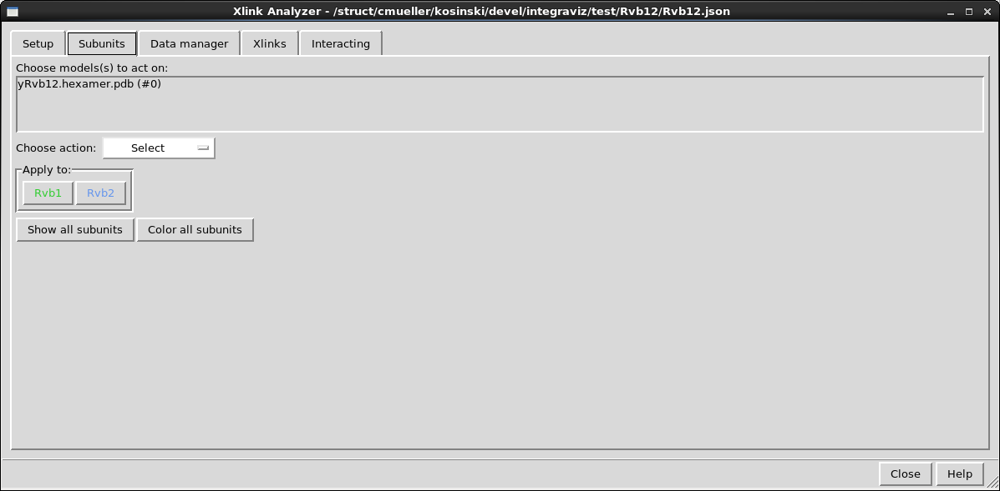

* 1. 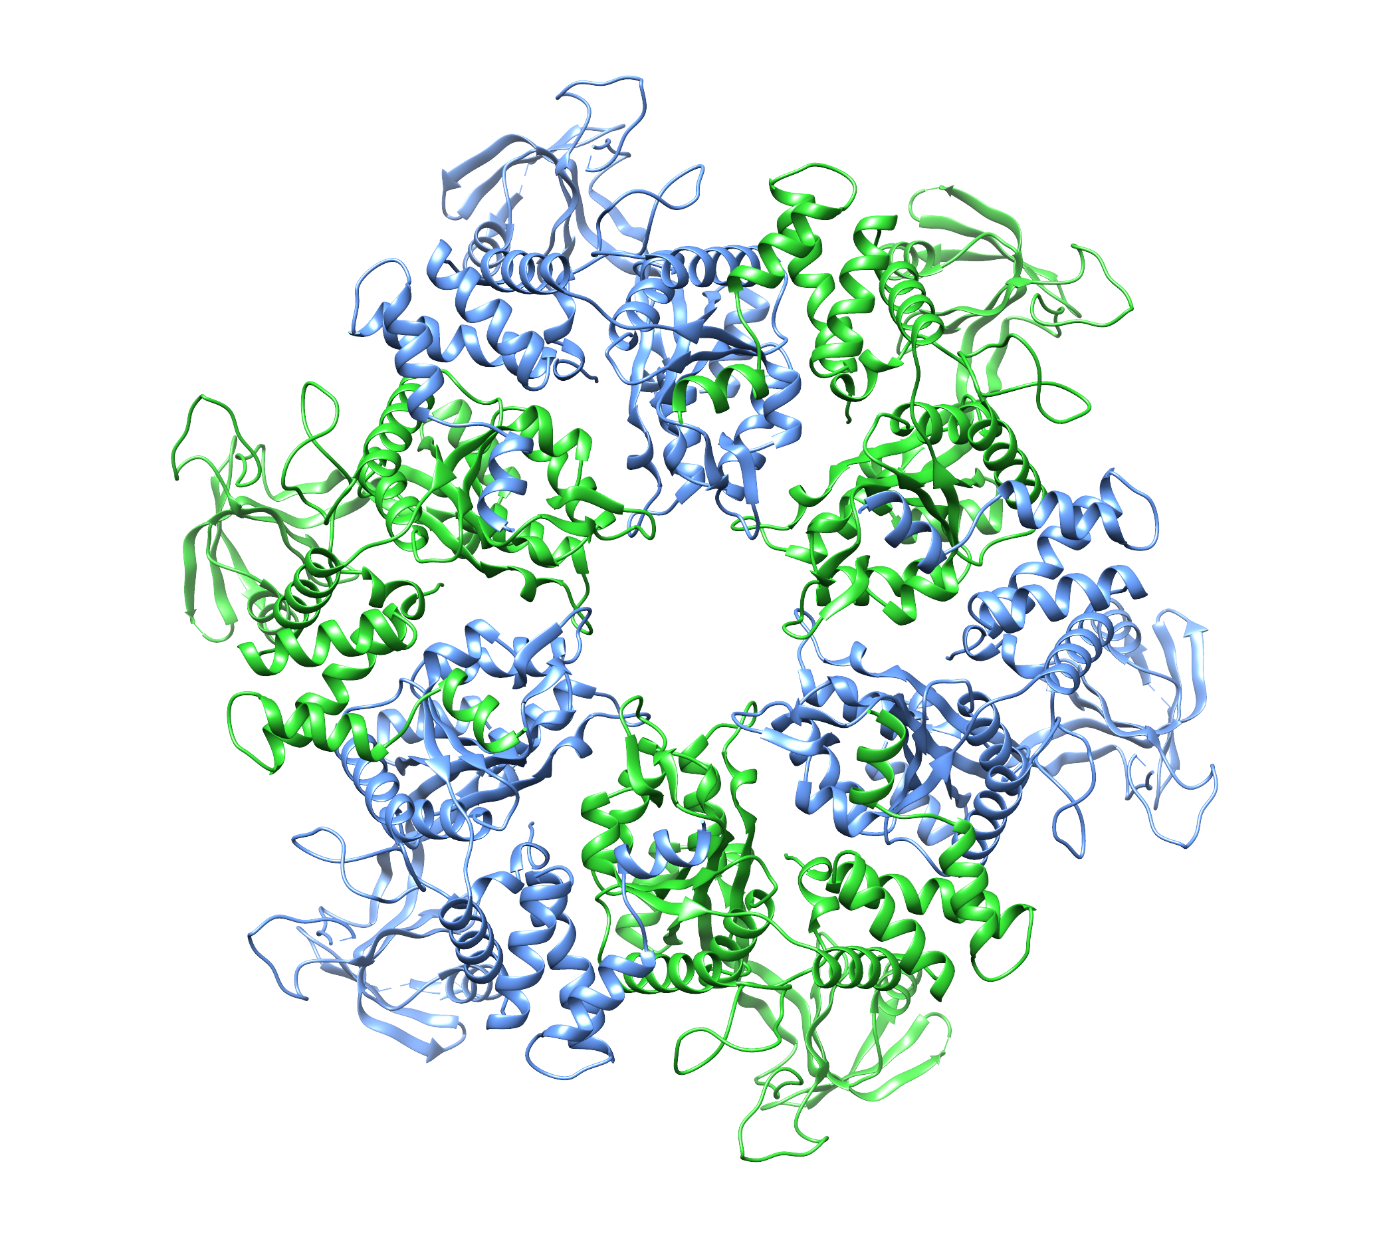Select the model in *Choose model(s) to act on* and click *Color all subunits* button. You structure should get colored like this:
  2. Test different actions. You can select, hide etc. individual subunits according to your needs.
  3. Show all subunits back by clicking *Show all subunits*

### Add cross-linking data

1. Go back to *Setup* tab
2. Fill out the data form:
   1. In Name: type “xlinks”
   2. Load data files: browse files, navigate to the *xlinks* directory in your project directory (which you created in the first steps of the tutorial), and select all files (*inter.csv*, *intra.csv*, *monolinks.csv*). You can select multiple files in usual way with ctrl-clik, shift, etc.
   3. Click on *Data type* and choose *xquest* in the drop down menu.

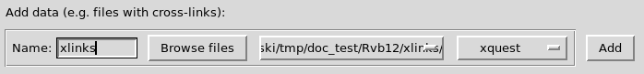

* 1. Click Add
  2. A row should appear below in the *Data sets* panel:

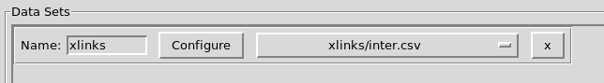

* 1. Match the of protein names to subunit names:
     1. Click *Configure*

A new window opens:

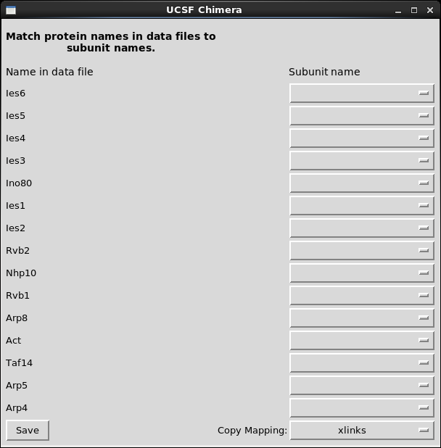

The window lists all protein names found in the cross-link files.

* + 1. Choose appropriate subunit names in the drop down menus. Don’t worry about the names that cannot be mapped to any subunits – in this tutorial we analyze only Rvb12 hexamer.

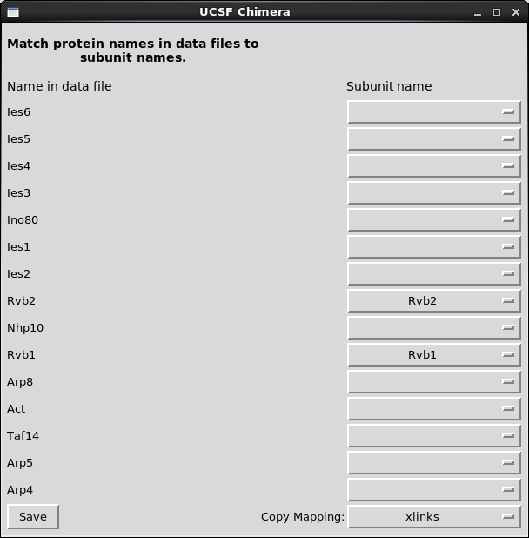

* + 1. Click Save.

### Add sequence data [optional]

Optionally, you can add sequences as data. The sequences are only necessary if you want to use a feature of predicting non expected monolinks (see Display modified).

1. Copy *sequences.yeast.fasta* from example/Rvb12 to your project directory
2. Add the sequences using the Add data interface as above for cross-links.
   1. Fill the name
   2. Browse the fasta file
   3. Select *sequences* data type
   4. Configure the names

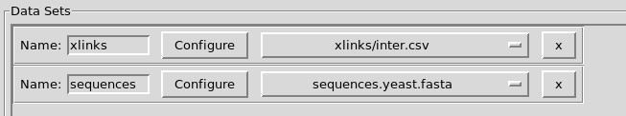

### Save the project

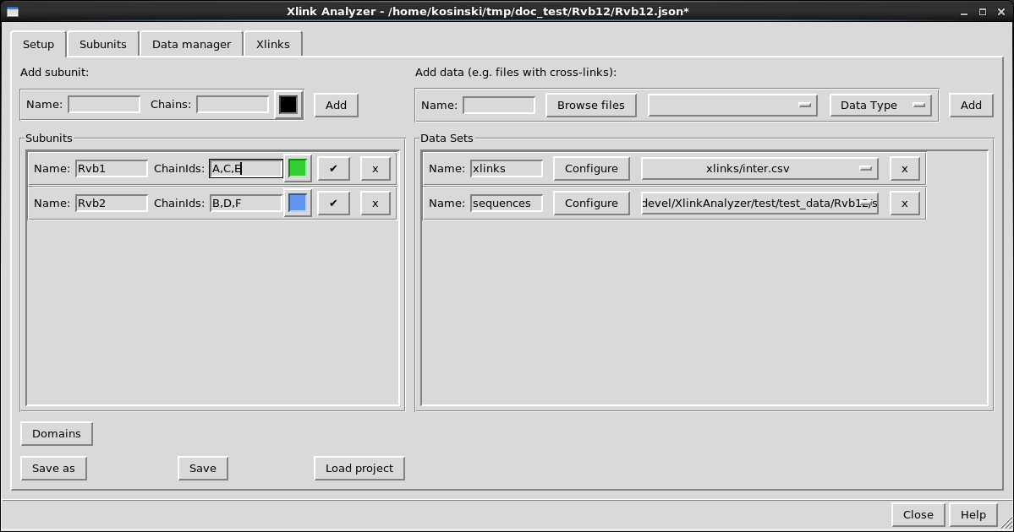Save the final project using “Save” button.

* If you close your Chimera session, you can open the project later using *Load project* button.
* You can copy the project directory to different computer and load the project there
* You can zip the entire directory and send the zip to a collaborator, who then will be able to load the project on his/her computer.

## Display cross-links

1. Switch to *Xlinks* tab

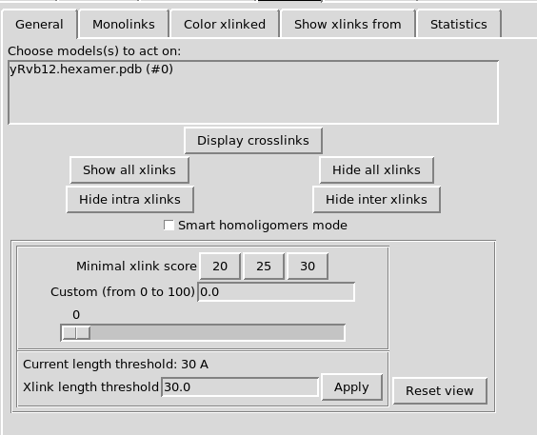

1. Select the model
2. Click *Display cross-links*

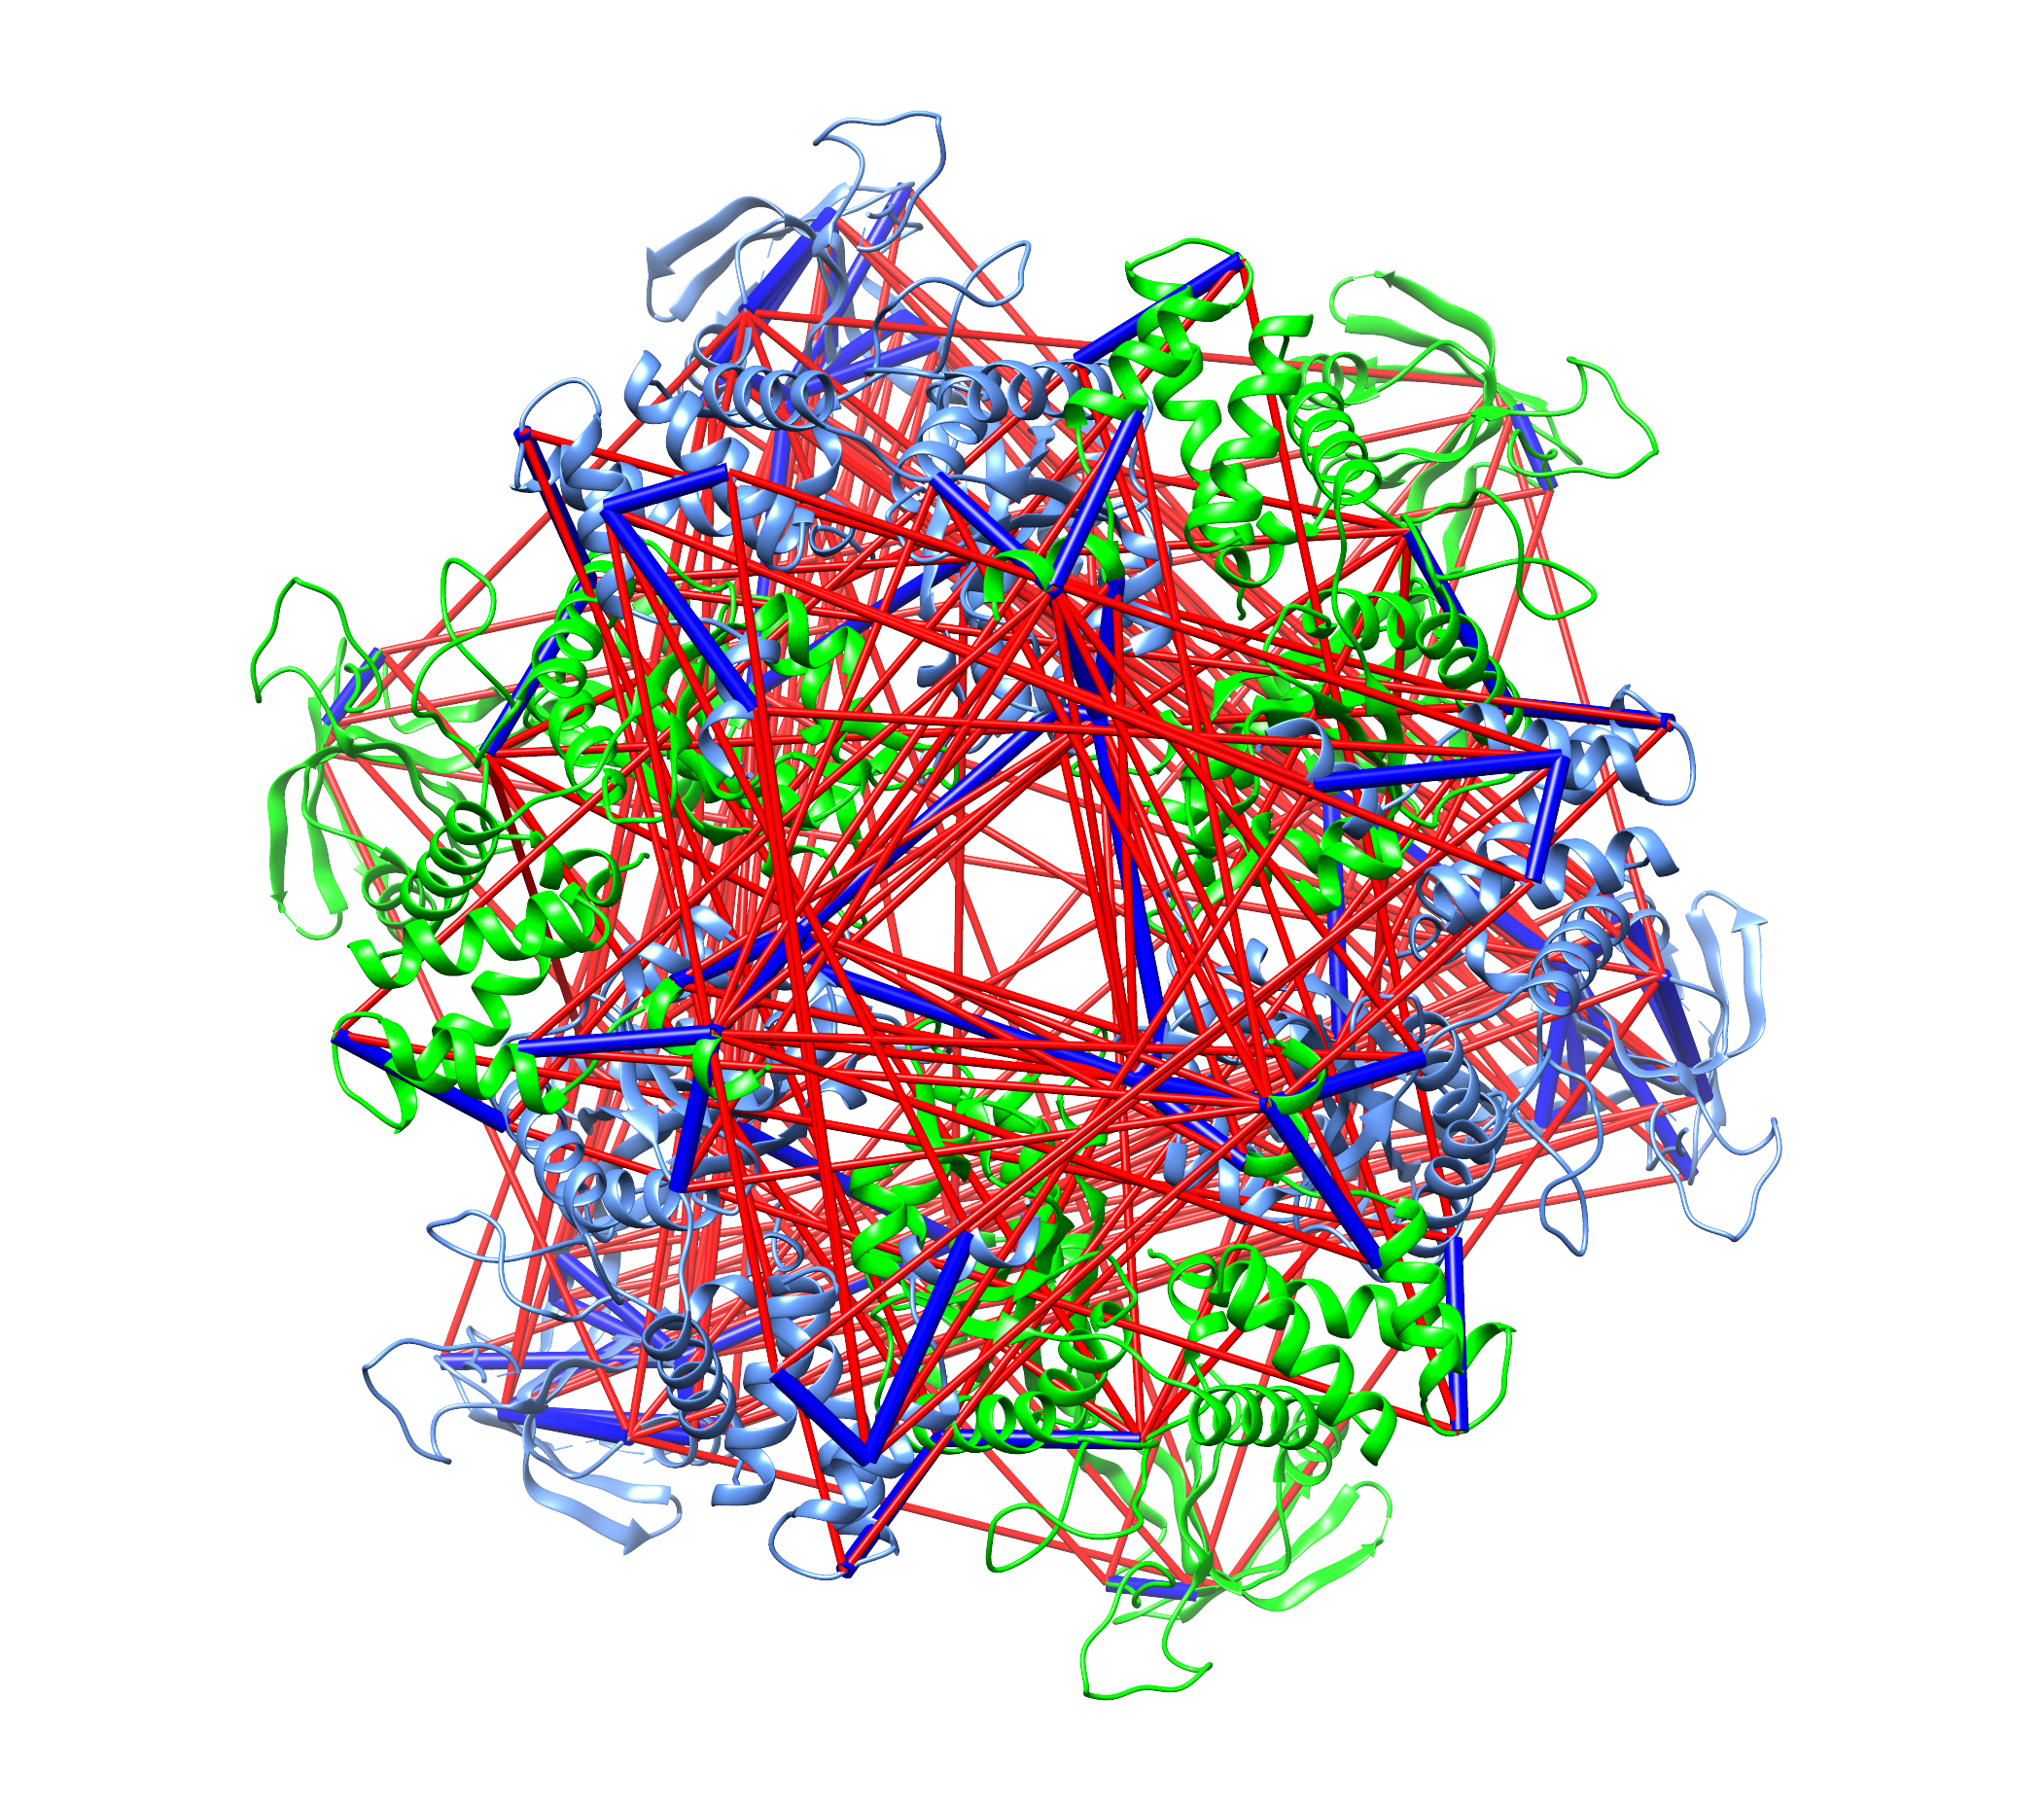

1. Select *Smart homoligomers mode*. This will hide cross-links that are redundant due to multiple copies of the same subunit.

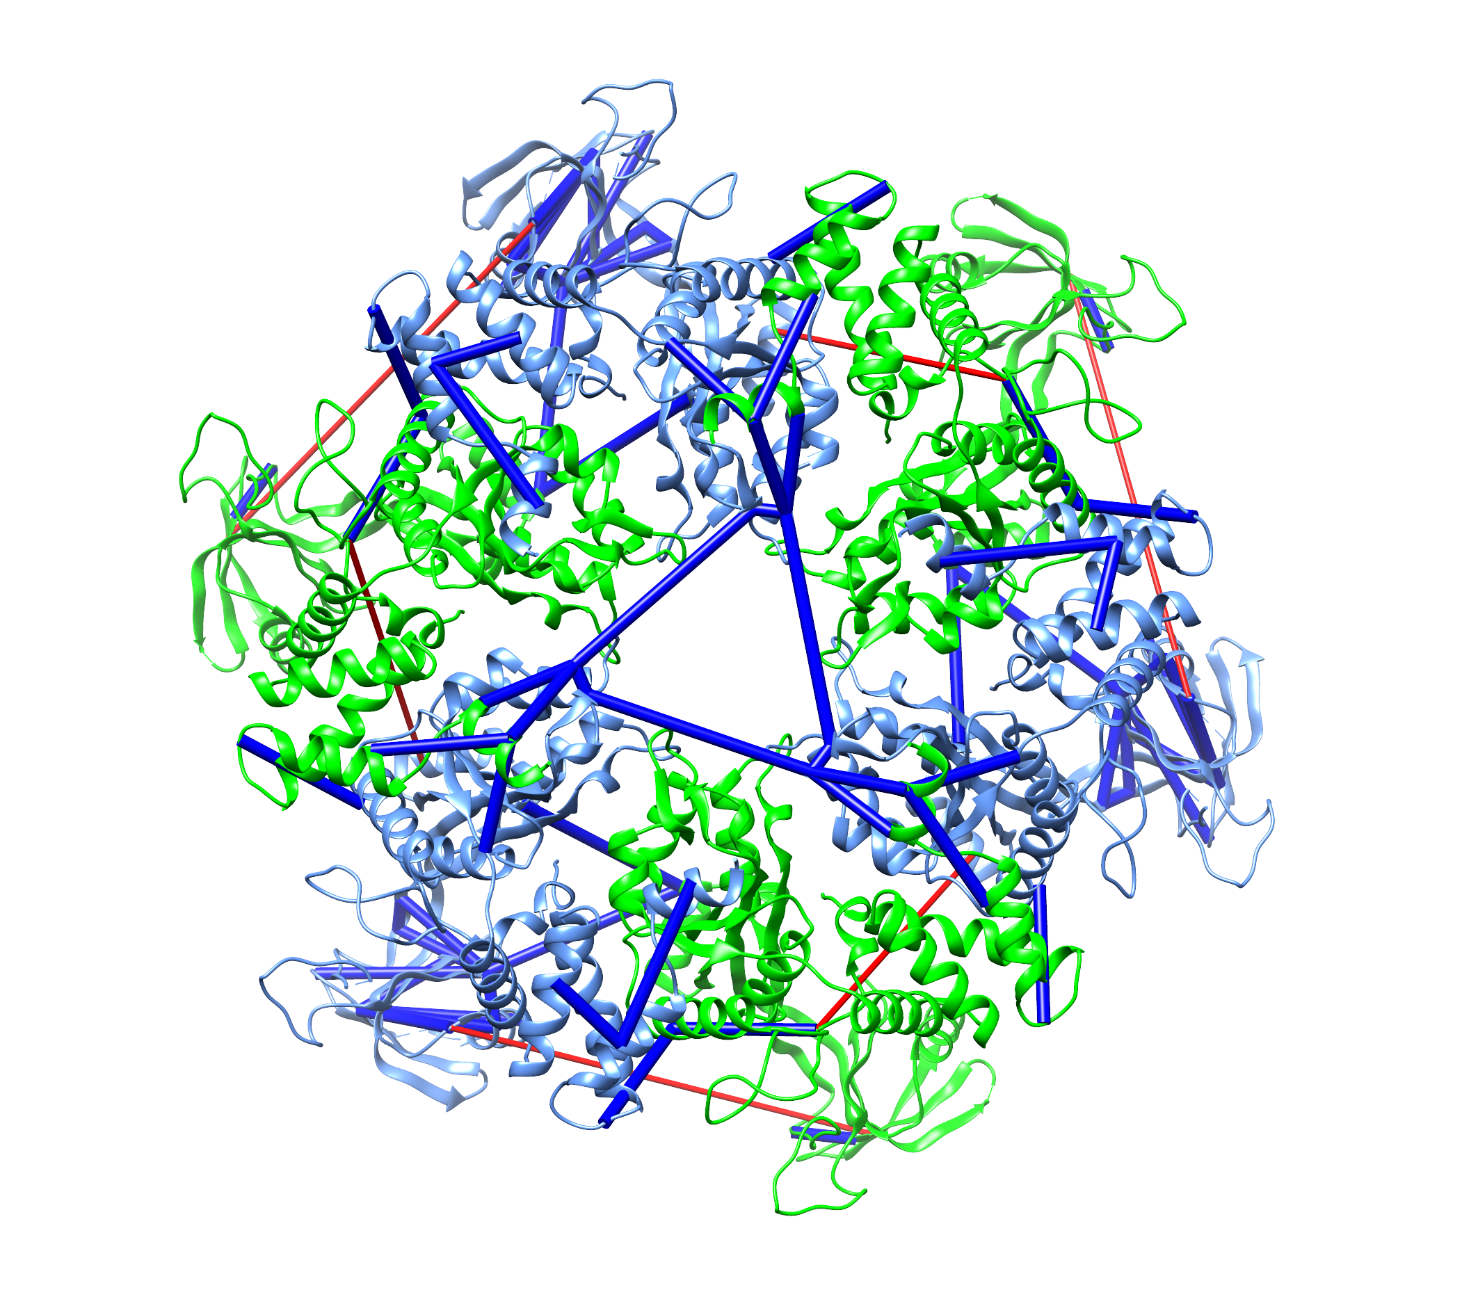

1. Adjust ld-score to 30 using *Minimal xlink score*. This is recommended threshold that minimize false cross-links.

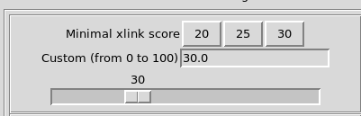

1. Some less confident cross-links with score below 30 disappear.
2. Take a look at the structure. You can see that most of the cross-links are blue, which means they are satisfied by the structure given the current distance threshold (30 Å). Some cross-links are red, which means they violate the distance threshold and are not compatible with the structure. The cross-links connect however apparently flexible domains, thus they probably suggest conformational changes!

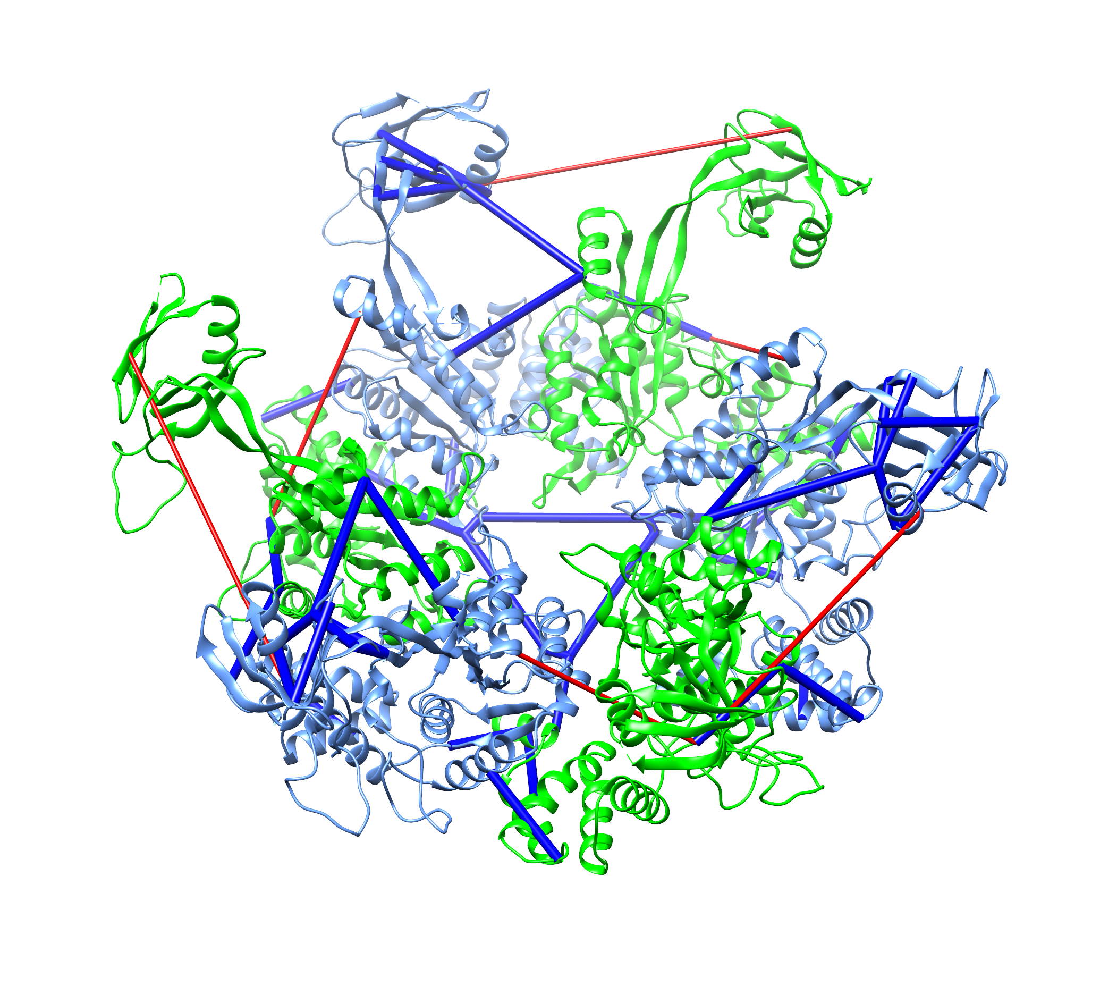

1. Play around with the interface. Hide intra-links or inter-links and re-display all cross-links with *Show all xlinks*.

## Display modified

1. Switch to *Modified* tab

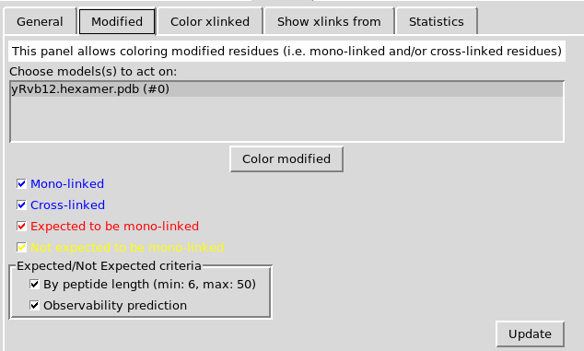

1. Click *Color modified* button
2. All lysine residues get displayed as spheres. Modified lysine residues (cross-linked or mono-linked) are colored blue. Expected to be modified – red, not expected – yellow.  
   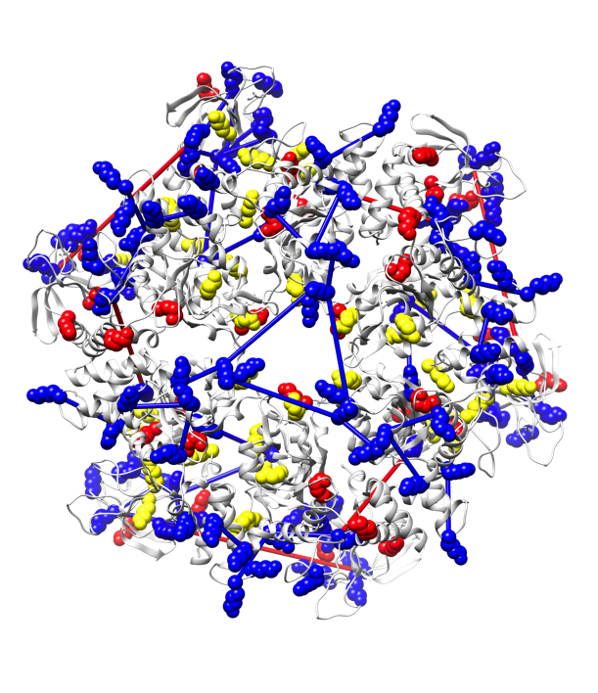
3. Hide all cross-links (Tab General -> Hide all xlinks)
4. Display surface (Chimera Menu Actions -> Surface -> show), rotate the structure to see the surface opposite to the above and notice that positions expected to be modified cluster in the center of the ring suggesting a buried interface for a second Rvb1/2 hexamer there.  
   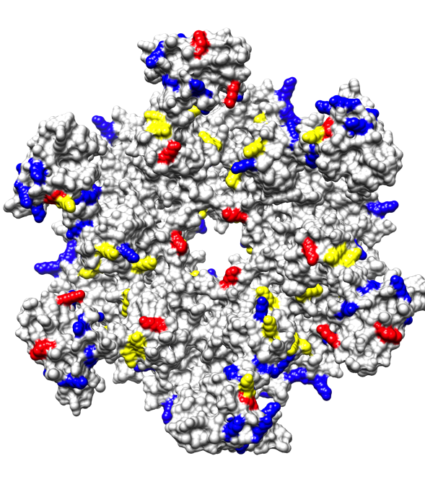

## Statistics

1. Hide surface (Chimera Menu Actions -> Surface -> hide)
2. Reset view (Xlink Analyzer -> Xlinks -> General tab -> Reset view). This will hide the sphere representation and re-show the xlinks
3. Re-color the structure (Xlink Analyzer -> Subunits -> Color all subunits)
4. Switch to Xlinks -> Statistics tab
5. Make sure xlink score is set to 30
6. Click *Refresh*.   
   You should see a table summarizing the statistics on satisfied and violated cross-links.   
   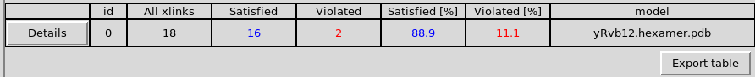  
   With *Export table* button you can export this table to a text file and open in Excel.  
   Note, that if multiple structures are opened, this table allows comparing the cross-link satisfaction between the structures.
7. Click *Details* button. Scroll down if necessary.  
   You will see a detailed list of which subunits and subunit pairs are involved in violations. With appropriate buttons you can highlight the violated cross-links in the structure, show distance histogram of cross-linked residues or export the violated cross-links to CSV file and open it in Excel.  
   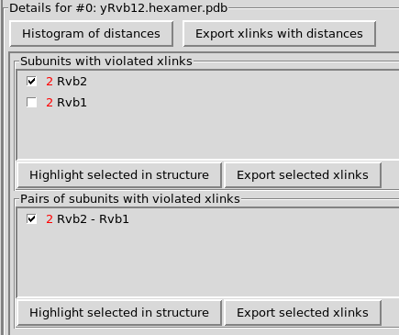  
   Histogram exported as PNG file  
   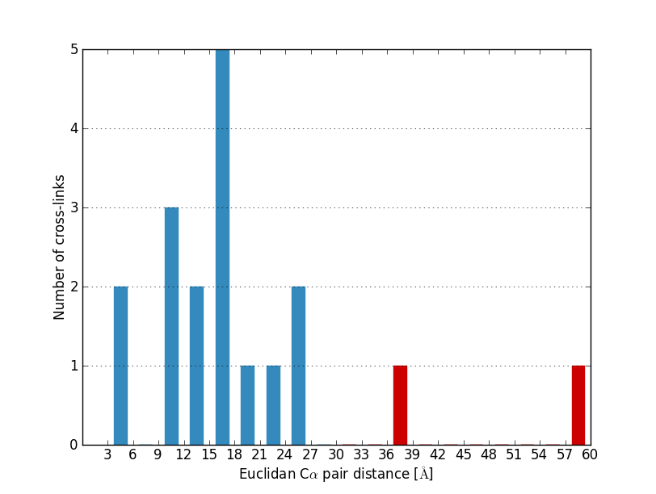

## Show cross-linking from

With this panel you can display cross-links between specific subunits. Choose Rvb1 in one drop down menu and Rvb2 in another. Click Show.

This feature is very useful in the case of big complexes. Thus, analyze Pol I example:

1. Close and re-open Chimera
2. Start Xlink Analyzer
3. To load Pol I project from example directory:  
   Setup -> Load project  
   and browse example/PolI/PolI.json file.
4. Open Pol I PDB file:  
   example/PolI/4C3H.pdb
5. Color subunits: *Subunits tab -> select 4C3H.pdb -> Color all subunits*
6. Display cross-links: *Xlinks tab -> General tab -> Display cross-links*
7. Set score threshold to 30
8. Switch to *Show xlinks from* tab  
   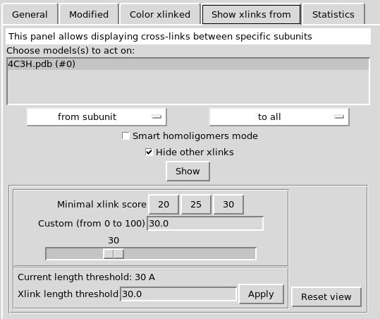
9. In *from subunit* choose A190
10. In *to subunit* choose A135  
    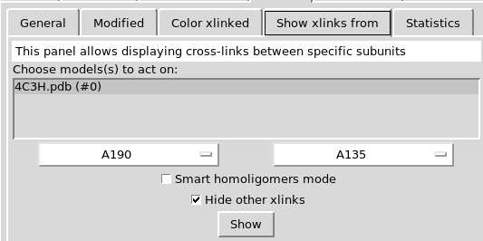
11. Click *Show*  
    You can see that now only cross-links between the two subunits are displayed.  
    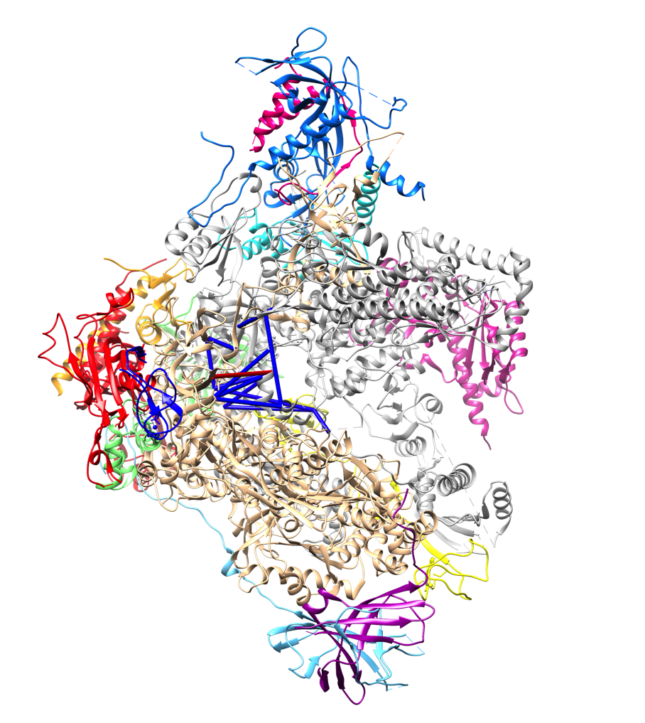
12. To focus on these cross-links even better, hide other subunits:
    1. Switch to *Subunits* tab
    2. In *Choose action:* choose *Show only*
    3. Click on *A190* button
    4. In *Choose action:* choose *Show*
    5. Click on *A135* button
13. Now you can analyze the cross-links between the two subunits more clearly:  
    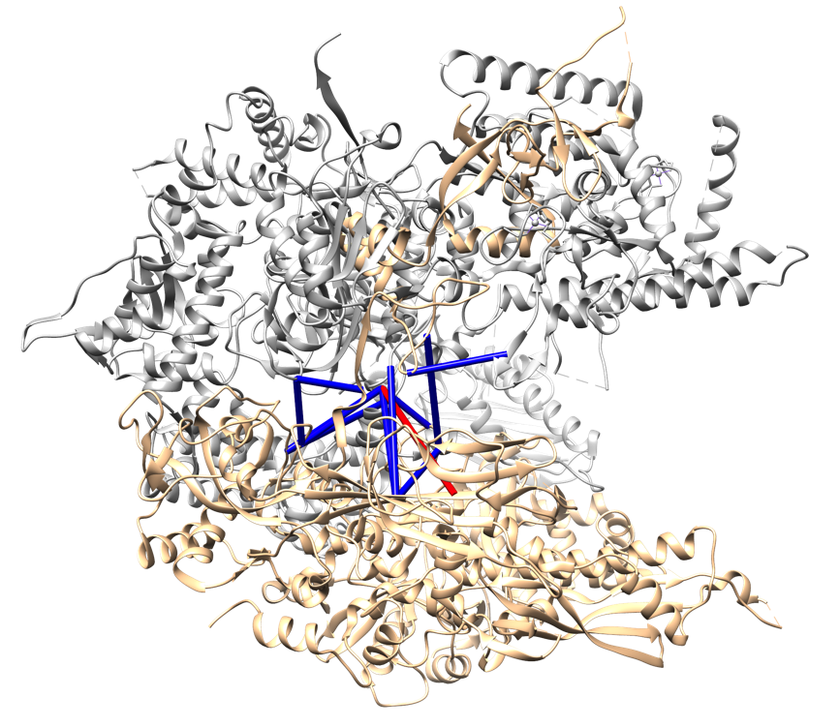

## Identify residues cross-linking to other subunits

1. In the Pol I example, re-display all subunits:  
   *Subunits* tab -> *Show all subunits*
2. Reset view:  
   *Xlinks* tab -> *General* -> *Reset view*
3. Switch to *Color xlinked* tab  
   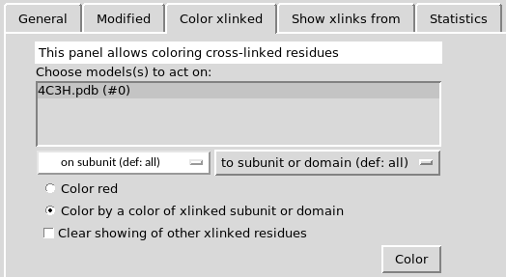
4. Select *Color by a color of xlinked subunit or domain* checkbox
5. In *To subunit or domain* select *A49*  
   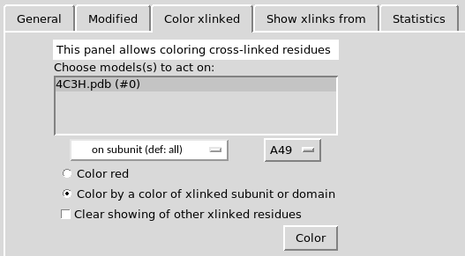
6. Click *Color*Residues that cross-link to A49 are displayed as magenta spheres. Note that some residues identified as cross-linked to A49 are not linked to A49 by cross-link bonds. The bonds are missing because these residues cross-link to regions of A49 missing in the structure.  
   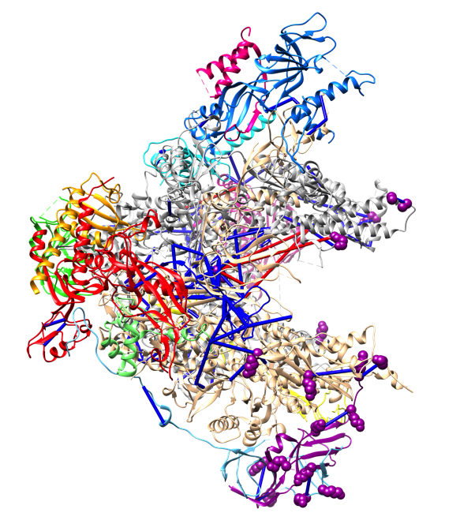
7. It is known that A49 contains tandem winged helix (tWH) domain corresponding to residues 172-403 and this domain is missing in the Pol I structure. Xlink Analyzer allows you specify domains of your subunits and then show residues cross-linking to these domains.
8. Switch to *Setup* tab
9. Click *Domains* button. A window will open:  
   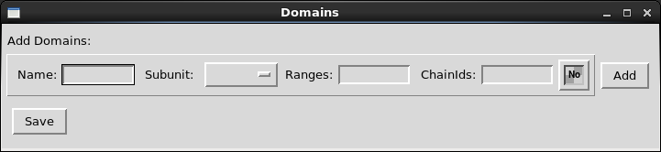
10. Fill the fields as following (setting color to “dark red”):  
    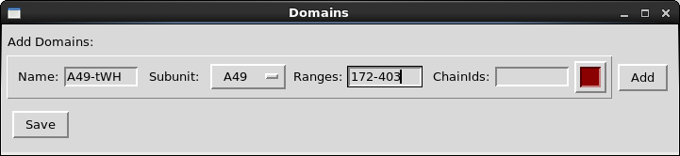
11. Click Add and Save.
12. Got to *Color xlinked* tab again, and select A49-tWH domain in the drop down menu:  
    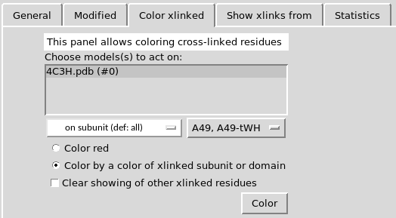
13. Click *Color*. Residues that cross-link to the tWH domain are now colored red. This allows you to approximately position the tWH domain within the complex:  
    